Homework 1

Problem 1
We filter by DHCP. We see that the client requested IP 192.168.20.11 (No. 1254), but was Not Acknowledged (No. 1255). After that the client send a Discover (No. 1256) and received an Offer (No. 1257) for the IP 192.168.30.11, then the client Requested IP 192.168.30.11 (No. 1258), which was Acknowledged (No. 1259).
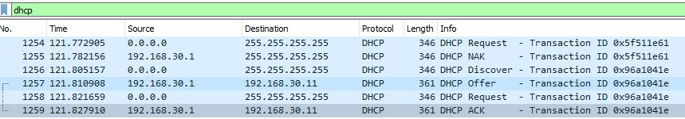
The answer is: 192.168.30.11.

Problem 2
We filter by NTP and see that the source (2003:41:6012:121::10) send a NTP packet (No. 2918) and then received one from the destination (2003:41:6012:110::dcf7:123), which had the mode flag set to Server.
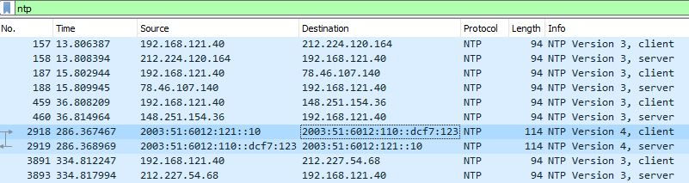
The answer is: 2003:41:6012:110::dcf7:123.

Problem 3
We filter by DNS and see that in the pachet No. 2620, the authoritative name server for the domain blog.webergetz.net were ns1.hans.hosteurope.de and ns2.hans.hosteurope.de.
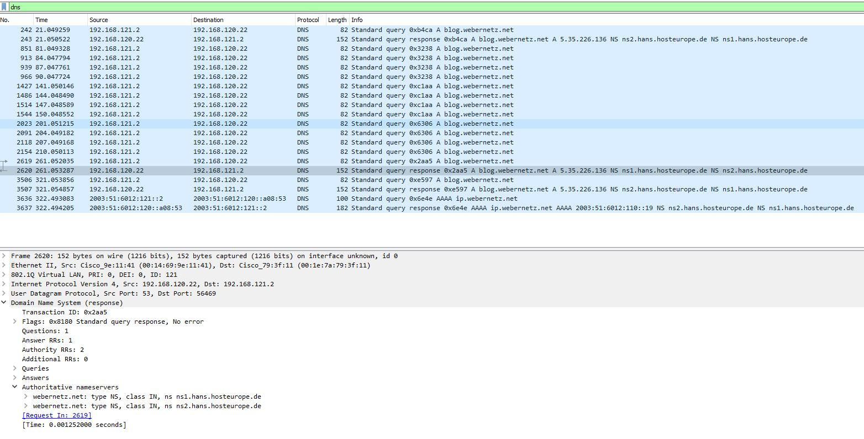
The answer is: ns1.hans.hosteurope.de.

Problem 4
We filter by CDP and see in packet No. 133 (the first packet from CCNP-LAB-S2) that the Port ID for CCNP-LAB-S2 is GigabitEthernet0/2.
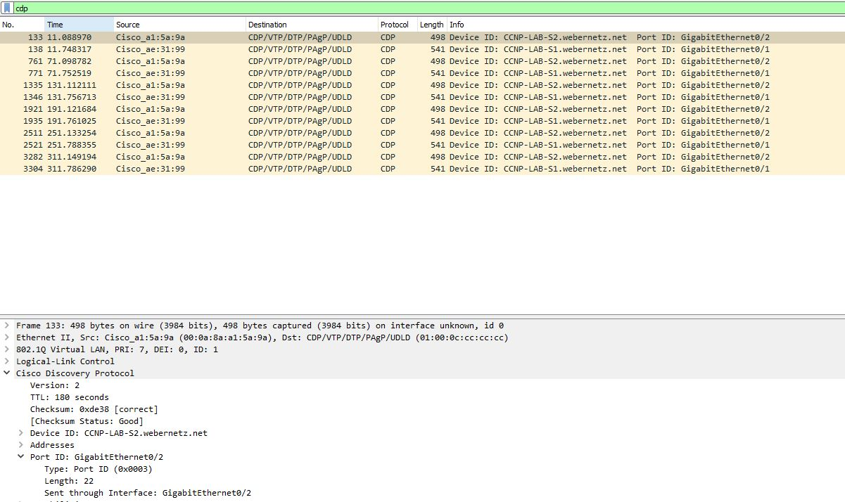
The answer is: GigabitEthernet0/2.
Problem 5
We filter by CDP and see in packet No. 133 (the first packet from CCNP-LAB-S2) that the IOS Software Version for CCNP-LAB-S2 is: Version 12.1(22)EA14.
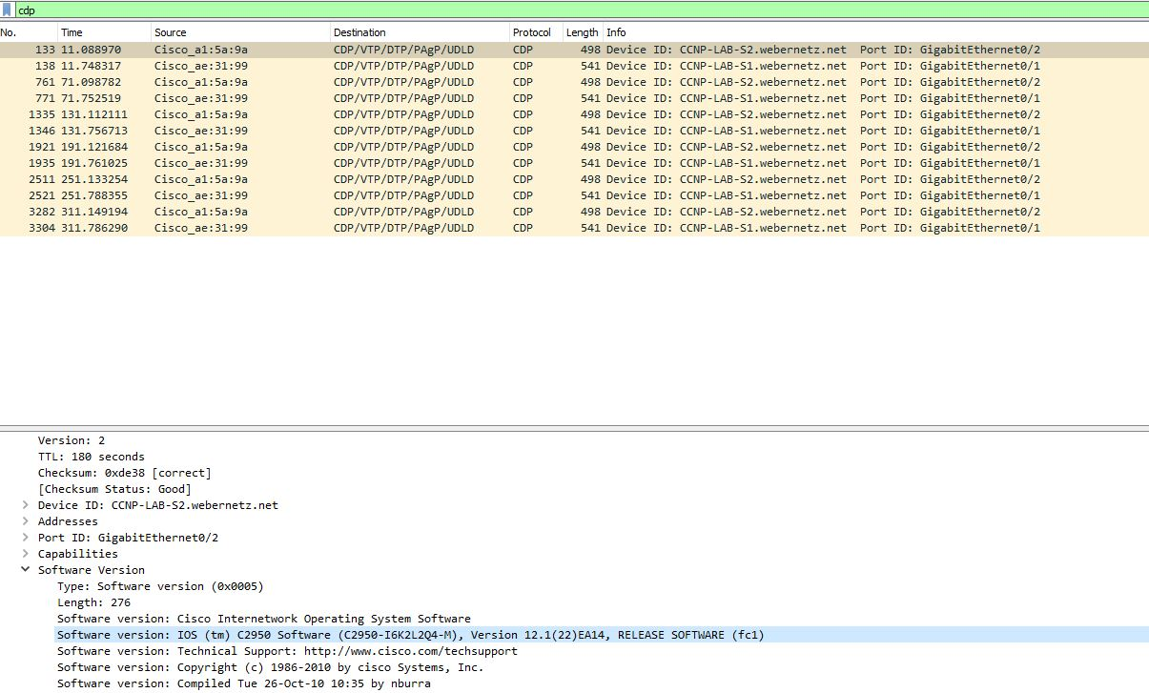
The answer is: Version 12.1(22)EA14.

Problem 6
I searched online “NVRAM config”and found out this:
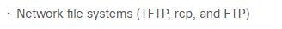
So I wanted to search by TFTP and see which contain NVRAM, so I filtered by TFTP contains "NVRAM" and found this in packet No. 3770:
!
! Last configuration change at 20:55:45 UTC Fri Mar 3 2017 by weberjoh
! NVRAM config last updated at 21:02:36 UTC Fri Mar 3 2017 by weberjoh
! NVRAM config last updated at 21:02:36 UTC Fri Mar 3 2017 by weberjoh
version 15.1
service timestamps debug datetime msec
service timestamps log datetime msec
service password-encryption
!
hostname CCNP-LAB-R2
!
boot-start-marker
boot-end-marker
!
!
enable secret 5 $1$Z.9j$Nvobsx9NvJzqtRLQqR.9b0
!
aaa new-model
!
!
aaa group server radius foobar
server name blubb
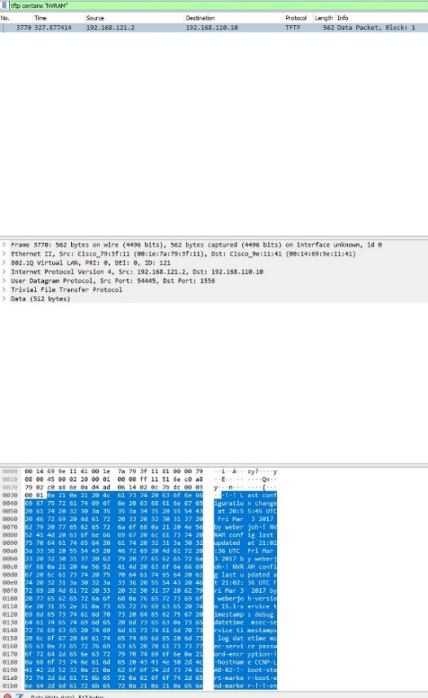
The answer is: 21:02:36 UTC Fri Mar 3 2017.

